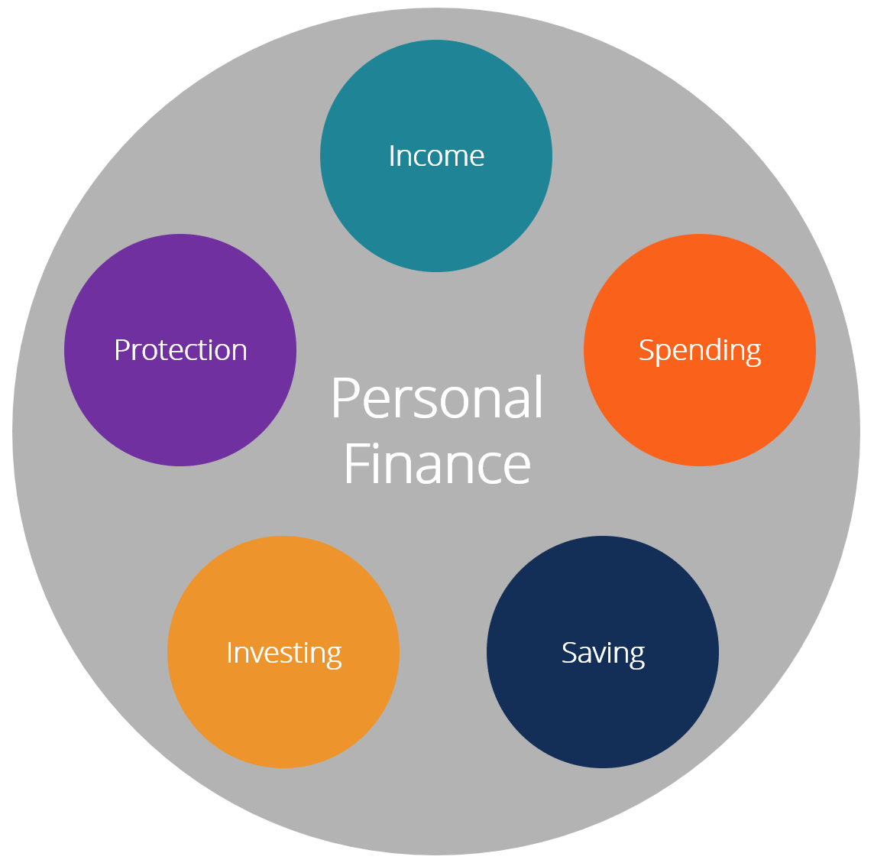

**Budgeting:**

Budgeting starts with tracking how much money you receive every month, minus how much money you spend every month. You can track this in an Excel sheet, on paper, or in a budgeting app—it's up to you. Wherever you track your budget, clearly lay out the following:

* **Income:** List all sources of money you receive in a month, with the dollar amount. This can include paychecks, investment income, alimony, settlements, and more.
  + Salaries
  + Bonuses
  + Hourly wages
  + Pensions
  + [Dividends](https://corporatefinanceinstitute.com/resources/knowledge/finance/dividend/)
* **Expenses**: List every purchase you make in a month, split into two categories—[fixed expenses](https://www.investopedia.com/terms/f/fixedcost.asp) and [discretionary spending](https://www.investopedia.com/terms/d/discretionary-expense.asp). If you can't remember where you're spending money, review your bank statements, credit card statements, and brokerage account statements. ***Fixed expenses*** are the purchases you must make every month, and whose amounts don't change (or change very little), and are considered essential. This includes rent/mortgage payments, loan payments, and utilities. ***Discretionary spending*** is the nonessential, or varying purchases you make on things like restaurant meals, shopping, clothing, and travel. Consider them as "wants" rather than "needs."
  + Rent
  + [Mortgage payments](https://corporatefinanceinstitute.com/resources/knowledge/finance/mortgage/)
  + Taxes
  + Food
  + Entertainment
  + Travel
  + [Credit card payments](https://corporatefinanceinstitute.com/resources/knowledge/other/best-buy-credit-card/)
* **Savings**: Record the amount of money you're saving each month, whether it's in cash, cash deposited into a bank account, or investments in a brokerage account.
  + Physical cash
  + Savings bank account
  + Checking bank account
  + [Money market securities](https://corporatefinanceinstitute.com/resources/knowledge/trading-investing/what-is-money-market/)

**Curb your spending:** [**The envelope system**](https://www.nerdwallet.com/blog/finance/envelope-system/)

If you need a rigid system to help you reduce frivolous spending or stay out of debt but don’t want to track every purchase, try this cash-based approach. You set a spending limit for each expense category, like groceries, fill envelopes with the allotted cash and use only that money for purchases. Once an envelope is empty, you can’t spend any more money on that particular category for the month.

“Our brains are wired so that something tactile in front of you that you can smell and feel is more real than something on your phone or a number in your bank account,” says Daniel Chong, a certified financial planner in Irvine, California. “If you can’t seem to get a grasp on a certain spending category, then cash is king.”

The [Goodbudget](https://www.nerdwallet.com/blog/finance/goodbudget-app-review/) app is based on the envelope system, for those who like the method but don't want to deal with paper envelopes.

**» MORE:**[Try this free budget worksheet](https://www.nerdwallet.com/blog/finance/budget-worksheet/)

**Build up your savings:** [**Pay yourself first**](https://www.nerdwallet.com/blog/finance/pay-yourself-first-reverse-budgeting-explained/)

Designed to align your spending and values, this “reverse” budget puts savings before immediate expenses. With this system, you decide how much to set aside from your monthly income for savings goals like retirement and an emergency fund, then use the rest for bills and other costs — so you don’t have to crunch every number.

**Make the most of every dollar:** [**The zero-based budget**](https://www.nerdwallet.com/blog/finance/zero-based-budgeting-explained/)

This budget suits overspenders and meticulous planners alike. It makes monitoring your spending clear. You take your monthly income and use every dollar in a deliberate way — like saving a certain amount for a trip and paying for utilities and groceries — until there are zero dollars left. But if you don’t strictly use cash as with the envelope system, you’ll have to log each expense to make sure you’re on budget. [Budget apps](https://www.nerdwallet.com/blog/finance/budgeting-saving-tools/) such as YNAB and EveryDollar can help you follow a zero-based budget.

### **List Categories of Discretionary Expenses**

Next, [identify your discretionary expenses](https://www.consumerfinance.gov/about-us/blog/track-your-spending-with-this-easy-tool/). These are things you can go without but often choose to spend money on. They are wants, rather than needs, and may include:

* Fitness memberships
* Clothing
* Cable TV
* Streaming subscriptions
* Eating out
* Leisure travel
* Personal grooming
* House cleaning
* Home decor

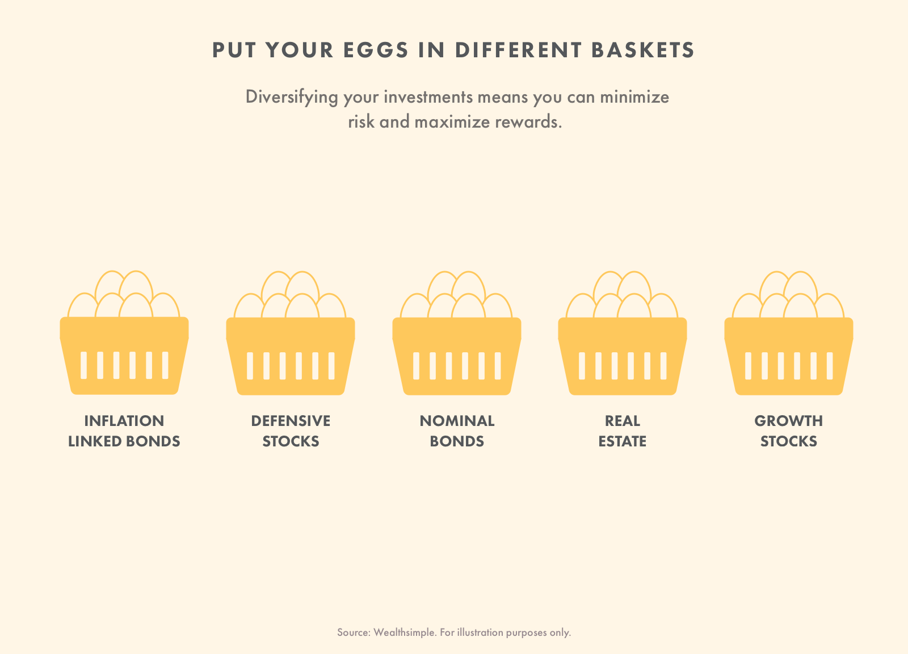

**Investing:**

### What should I invest in?

There's no right answer for everyone. What securities you buy, and how much you buy, depends on the amount of money you're comfortable using, and how much risk you're willing to take. Here are the most common securities to invest in, in descending order of risk:

[**Stocks**](https://www.investopedia.com/terms/s/stock.asp): A stock (also known as "shares" or "equity") is a type of investment that signifies ownership in the issuing company. This entitles the stockholder to that proportion of the corporation's assets and earnings. Essentially, it's like owning a small piece of the company. However, if you own 33% of the shares of a company, it is incorrect to assert that you own one-third of that company; it is instead correct to state that you own 100% of one-third of the company’s shares. Shareholders cannot do as they please with a company or its assets.

[**ETFs**](https://www.investopedia.com/terms/e/etf.asp)**:** An exchange-traded fund (ETF) is a type of security that involves a collection of securities—such as stocks—that often tracks an underlying [index](https://www.investopedia.com/terms/i/index.asp), although ETFs can invest in any number of industry sectors or use various strategies. Think of ETFs as a pie containing many different securities. When you buy shares of an ETF, you're buying a slice of the pie, which contains slivers of the securities inside. This lets you purchase many stocks at once, with the ease of only making one purchase—the ETF.

[**Mutual funds**](https://www.investopedia.com/terms/m/mutualfund.asp): A mutual fund is a type of investment consisting of a portfolio of stocks, bonds, or other securities. Mutual funds give small or individual investors access to diversified, professionally managed portfolios at a low price. There are several categories, representing the kinds of securities they invest in, their investment objectives, and the type of returns they seek. Most employer-sponsored retirement plans invest in mutual funds.

Investing in a share of a mutual fund is different from investing in shares of stock. Unlike stock, mutual fund shares do not give holders any voting rights and represent investments in many different stocks (or other securities) instead of just one holding. Unlike stocks or ETFs that trade throughout the day, many mutual fund redemptions​ take place only at the end of each trading day. Similar to ETFs, investing in mutual funds is considered less risky than stocks because many securities are contained within the mutual fund, spreading out the risk across multiple companies.

[**Bonds**](https://www.investopedia.com/terms/b/bond.asp): Bonds are issued by companies, municipalities, states, and sovereign governments to finance projects and operations. When an investor buys a bond, they're effectively loaning their money to the bond issuer, with the promise of repayment plus interest. A bond's coupon rate is the interest rate the investor will earn. A bond is referred to as a fixed income instrument since bonds traditionally paid a fixed interest rate (coupon) to investors. Bond prices are inversely correlated with interest rates: when rates go up, bond prices fall and vice versa. Bonds have maturity dates, which are the point in time when the principal amount must be paid back in full or risk default.

* [Stocks](https://corporatefinanceinstitute.com/resources/knowledge/finance/what-is-a-stock/)
* [Bonds](https://corporatefinanceinstitute.com/resources/knowledge/trading-investing/bonds/)
* [Mutual funds](https://corporatefinanceinstitute.com/resources/knowledge/trading-investing/mutual-funds/)
* [Real estate](https://corporatefinanceinstitute.com/resources/careers/jobs/real-estate/)
* [Private companies](https://corporatefinanceinstitute.com/resources/knowledge/valuation/private-company-valuation/)
* [Commodities](https://corporatefinanceinstitute.com/resources/knowledge/trading-investing/a-guide-to-commodity-trading-secrets/)
* Art

#### **#5 Protection**

Personal protection refers to a wide range of products that can be used to guard against an unforeseen and adverse event.

Common protection products include:

* Life insurance
* Health insurance
* [Estate planning](https://www.forbes.com/sites/bobcarlson/2018/04/20/avoiding-7-deadly-estate-planning-mistakes/)

### **The Personal Finance Planning Process**

Good financial management comes down to having a solid plan and sticking to it. All of the above areas of personal finance can be wrapped into a budget or a formal financial plan.

These plans are commonly prepared by personal bankers and investment advisors who work with their clients to understand their needs and goals and develop an appropriate course of action.

Generally speaking, the main components of the financial planning process are:

* Assessment
* Goals
* Plan development
* Execution
* Monitoring and reassessment